**Міністерство освіти і науки України**

**Національний технічний університет України**

**“Київський політехнічний інститут”**

**Факультет прикладної математики**

**Кафедра спеціалізованих комп’ютерних систем**

**Лабораторна робота № 3**

з дисципліни «Схемотехніка»

«Проектування регістра на потенціальних елементах»



Виконав :

Студент групи КВ-32

**Сидоренко Влад**

Перевірив:

Клятченко Я.М.

____________________________________

Київ 2015

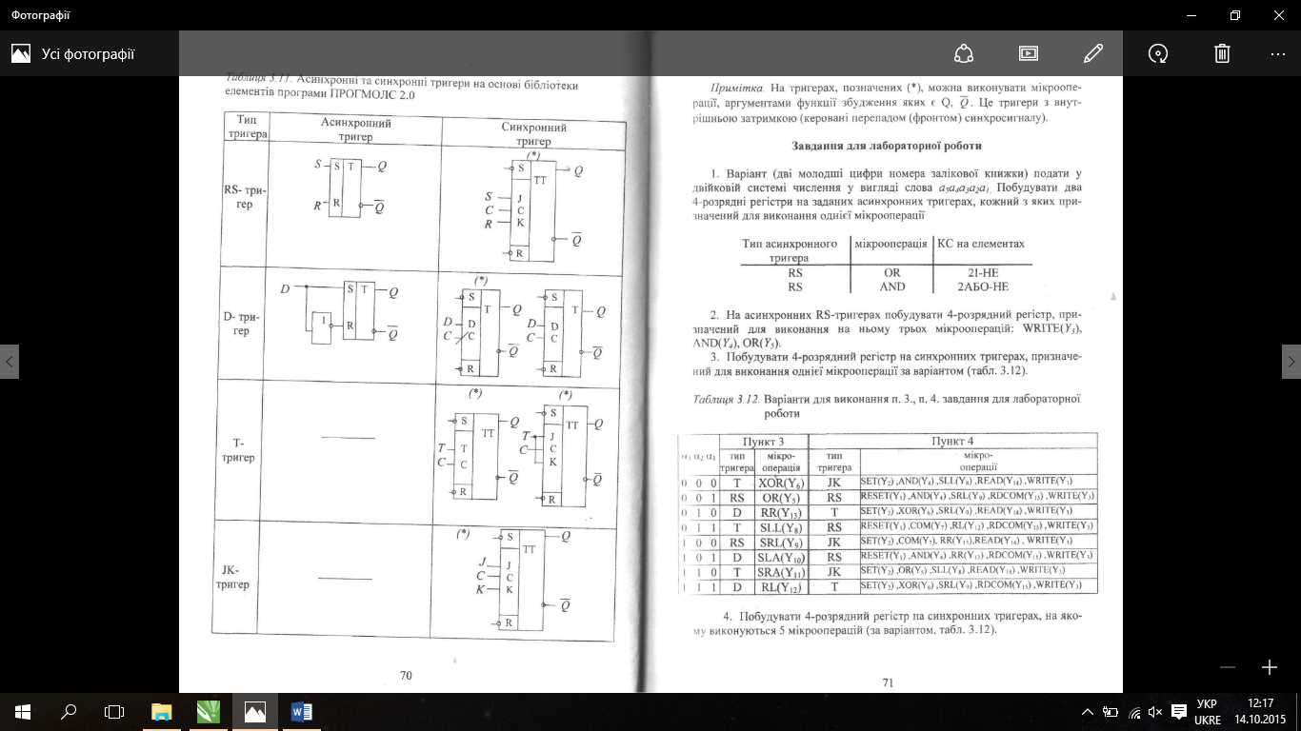





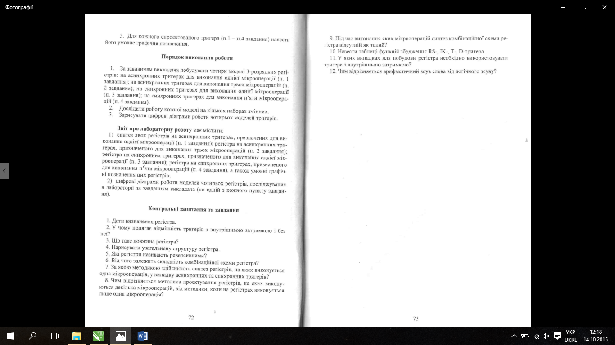

1. Синтез двох регістрів на заданих асинхронних тригерах

AND(Y4)

Qi(t+1) = Qi(t) & Xi(t)

|  |  |  |  |
| --- | --- | --- | --- |
| Q(t) | Q(t+1) | F1 | F2 |
| 0 | 0 | * | 0 |
| 0 | 1 | 0 | 1 |
| 1 | 0 | 1 | 0 |
| 1 | 1 | 0 | * |

|  |  |  |  |  |  |
| --- | --- | --- | --- | --- | --- |
| Y4 | X(t) | Q(t) | Q(t+1) | F1 | F2 |
| 0 | 0 | 0 | 0 | * | 0 |
| 0 | 0 | 1 | 1 | 0 | * |
| 0 | 1 | 0 | 0 | * | 0 |
| 0 | 1 | 1 | 1 | 0 | * |
| 1 | 0 | 0 | 0 | * | 0 |
| 1 | 0 | 1 | 0 | 1 | 0 |
| 1 | 1 | 0 | 0 | * | 0 |
| 1 | 1 | 1 | 1 | 0 | * |

|  |  |  |  |
| --- | --- | --- | --- |
| * | 0 | 1 | * |
| * | 0 | 0 | * |

|  |  |  |  |
| --- | --- | --- | --- |
| 0 | * | 0 | 0 |
| 0 | * | * | 0 |

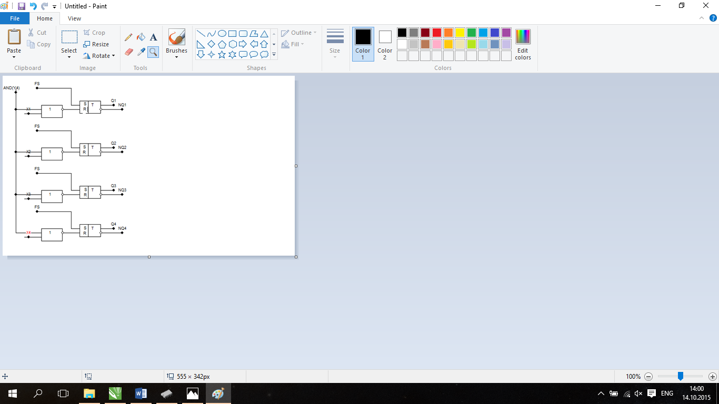

|  |  |  |  |
| --- | --- | --- | --- |
| Q(t) | Q(t+1) | F1 | F2 |
| 0 | 0 | * | 0 |
| 0 | 1 | 0 | 1 |
| 1 | 0 | 1 | 0 |
| 1 | 1 | 0 | * |

OR(Y5)

Qi(t+1) = Qi(t) v Xi(t)

|  |  |  |  |  |  |
| --- | --- | --- | --- | --- | --- |
| Y5 | X(t) | Q(t) | Q(t+1) | F1 | F2 |
| 0 | 0 | 0 | 0 | * | 0 |
| 0 | 0 | 1 | 1 | 0 | * |
| 0 | 1 | 0 | 0 | * | 0 |
| 0 | 1 | 1 | 1 | 0 | * |
| 1 | 0 | 0 | 0 | * | 0 |
| 1 | 0 | 1 | 1 | 0 | * |
| 1 | 1 | 0 | 1 | 0 | 1 |
| 1 | 1 | 1 | 1 | 0 | * |

|  |  |  |  |
| --- | --- | --- | --- |
| 0 | 0 | 0 | * |
| * | 0 | 0 | * |

|  |  |  |  |
| --- | --- | --- | --- |
| 1 | * | * | 0 |
| 0 | * | * | 0 |

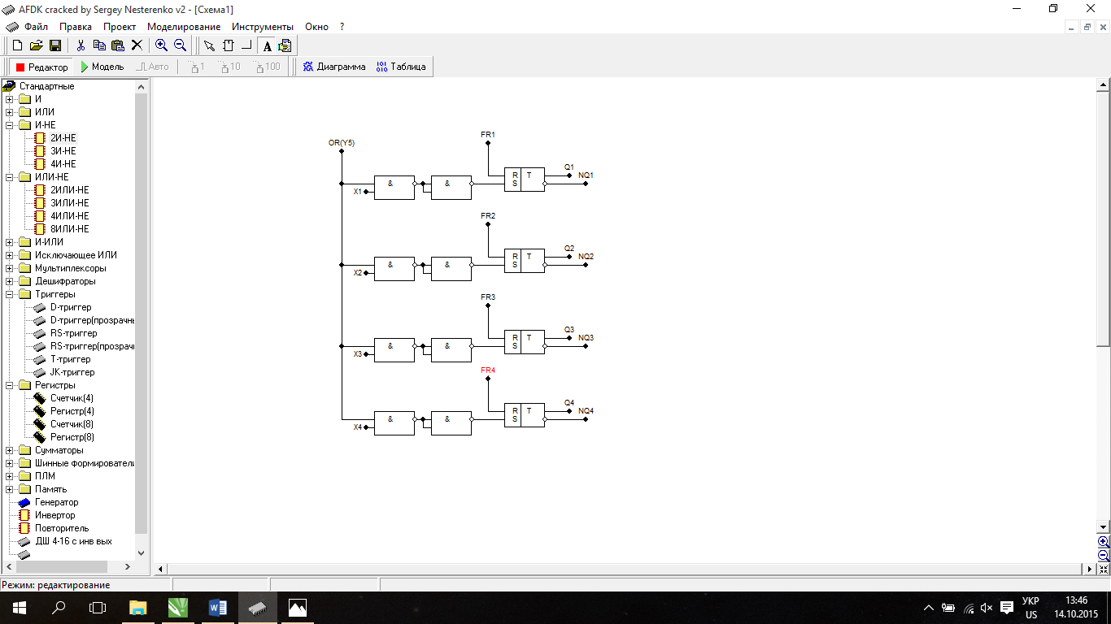

1. Чотирьохрозрядний регістр для трьох мікрооперацій на асинхронних RS-тригерах

|  |  |  |  |
| --- | --- | --- | --- |
| Q(t) | Q(t+1) | F1 | F2 |
| 0 | 0 | * | 0 |
| 0 | 1 | 0 | 1 |
| 1 | 0 | 1 | 0 |
| 1 | 1 | 0 | * |

WRITE(Y3) Qi(t+1) = Xi(t)

|  |  |  |  |  |  |
| --- | --- | --- | --- | --- | --- |
| Y3 | X(t) | Q(t) | Q(t+1) | F1 | F2 |
| 0 | 0 | 0 | 0 | * | 0 |
| 0 | 0 | 1 | 1 | 0 | * |
| 0 | 1 | 0 | 0 | * | 0 |
| 0 | 1 | 1 | 1 | 0 | * |
| 1 | 0 | 0 | 0 | * | 0 |
| 1 | 0 | 1 | 0 | 1 | 0 |
| 1 | 1 | 0 | 1 | 0 | 0 |
| 1 | 1 | 1 | 1 | 0 | * |

|  |  |  |  |
| --- | --- | --- | --- |
| 0 | 0 | 1 | * |
| * | 0 | 0 | * |

|  |  |  |  |
| --- | --- | --- | --- |
| 1 | * | 0 | 0 |
| 0 | * | * | 0 |

OR(Y5) Qi(t+1) = Qi(t) v Xi(t)

|  |  |  |  |  |  |
| --- | --- | --- | --- | --- | --- |
| Y5 | X(t) | Q(t) | Q(t+1) | F1 | F2 |
| 0 | 0 | 0 | 0 | * | 0 |
| 0 | 0 | 1 | 1 | 0 | * |
| 0 | 1 | 0 | 0 | * | 0 |
| 0 | 1 | 1 | 1 | 0 | * |
| 1 | 0 | 0 | 0 | * | 0 |
| 1 | 0 | 1 | 1 | 0 | * |
| 1 | 1 | 0 | 1 | 0 | 1 |
| 1 | 1 | 1 | 1 | 0 | * |

|  |  |  |  |
| --- | --- | --- | --- |
| 0 | 0 | 0 | * |
| * | 0 | 0 | * |

|  |  |  |  |
| --- | --- | --- | --- |
| 1 | * | * | 0 |
| 0 | * | * | 0 |

AND(Y4) Qi(t+1) = Qi(t) & Xi(t)

|  |  |  |  |  |  |
| --- | --- | --- | --- | --- | --- |
| Y4 | X(t) | Q(t) | Q(t+1) | F1 | F2 |
| 0 | 0 | 0 | 0 | * | 0 |
| 0 | 0 | 1 | 1 | 0 | * |
| 0 | 1 | 0 | 0 | * | 0 |
| 0 | 1 | 1 | 1 | 0 | * |
| 1 | 0 | 0 | 0 | * | 0 |
| 1 | 0 | 1 | 0 | 1 | 0 |
| 1 | 1 | 0 | 0 | * | 0 |
| 1 | 1 | 1 | 1 | 0 | * |

|  |  |  |  |
| --- | --- | --- | --- |
| * | 0 | 1 | * |
| * | 0 | 0 | * |

|  |  |  |  |
| --- | --- | --- | --- |
| 0 | * | 0 | 0 |
| 0 | * | * | 0 |

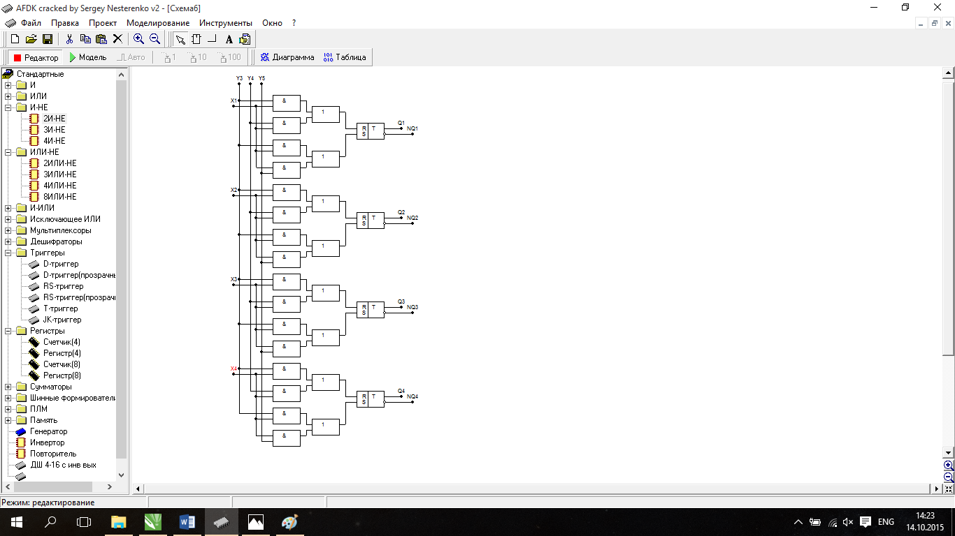

3.Синтез регістра на синхронних тригерах, на якому виконується одна мікрооперація

|  |  |  |
| --- | --- | --- |
| Q(t) | Q(t+1) | Ft |
| 0 | 0 | 0 |
| 0 | 1 | 1 |
| 1 | 0 | 0 |
| 1 | 1 | 1 |

|  |  |  |  |
| --- | --- | --- | --- |
| Qi-1(t) | Qi(t) | Qi(t+1) | Ft |
| 0 | 0 | 0 | 1 |
| 0 | 1 | 0 | 0 |
| 1 | 0 | 1 | 1 |
| 1 | 1 | 0 | 0 |

RR(Y13)

|  |  |
| --- | --- |
| 0 | 1 |
| 0 | 1 |

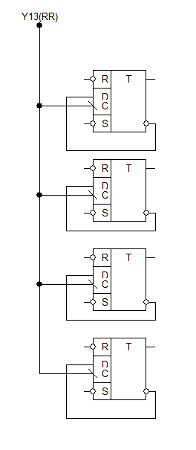

4.Синтез регістра на синхронних тригерах, на яких виконується декілька мікрооперацій

|  |  |  |
| --- | --- | --- |
| Q(t) | Q(t+1) | Ft |
| 0 | 0 | 0 |
| 0 | 1 | 1 |
| 1 | 0 | 1 |
| 1 | 1 | 0 |

1. SET – “1” на S
2. READ – Zi = Y14 * Qi
3. WRITE – Qi(t+1) = Xi(t)
4. XOR – Qi(t+1) = Qi(t) Xi(t)

|  |  |  |  |  |
| --- | --- | --- | --- | --- |
| Y6 | Xi(t) | Qi(t) | Qi(t+1) | Ft |
| 0 | 0 | 0 | 0 | * |
| 0 | 0 | 1 | 1 | 0 |
| 0 | 1 | 0 | 0 | * |
| 0 | 1 | 1 | 1 | 0 |
| 1 | 0 | 0 | 0 | 0 |
| 1 | 0 | 1 | 1 | 0 |
| 1 | 1 | 0 | 1 | 1 |
| 1 | 1 | 1 | 0 | 1 |

|  |  |  |  |
| --- | --- | --- | --- |
| 1 | 1 | 0 | 0 |
| 0 | 0 | 0 | 0 |

Ft(Y6) = Y6*Xi

|  |  |  |  |  |
| --- | --- | --- | --- | --- |
| Y9 | Xi(t) | Qi(t) | Qi(t+1) | Ft |
| 0 | 0 | 0 | 0 | * |
| 0 | 0 | 1 | 1 | 0 |
| 0 | 1 | 0 | 0 | * |
| 0 | 1 | 1 | 1 | 0 |
| 1 | 0 | 0 | 1 | 1 |
| 1 | 0 | 1 | 0 | 1 |
| 1 | 1 | 0 | 1 | 1 |
| 1 | 1 | 1 | 0 | 1 |

1. SRL –

|  |  |  |  |
| --- | --- | --- | --- |
| 1 | 1 | 1 | 1 |
| 0 | 0 | 0 | 0 |

Ft(Y9) = Y9

***Ft = Y6*Xi* v *Y9***

